## HARDWARE COMPONENTS

##### Motherboard

The motherboard serves as a single platform to connect all of the parts of a computer together. It connects the CPU, memory, hard drives, optical drives, video card, sound card, and other ports and expansion cards directly or via cables. It can be considered as the backbone of a computer.

The motherboard is mounted inside the case and is securely attached via small screws through predrilled holes. Motherboard contains ports to connect all of the internal components. It provides a single socket for CPU, whereas for memory, normally one or more slots are available. Motherboards provide ports to attach the floppy drive, hard drive, and optical drives via ribbon cables. Motherboard carries fans and a special port designed for power supply.

Features of Motherboard

A motherboard comes with following features −

* Motherboard varies greatly in supporting various types of components.
* Motherboard supports a single type of CPU and few types of memories.
* Video cards, hard disks, sound cards have to be compatible with the motherboard to function properly.
* Motherboards, cases, and power supplies must be compatible to work properly together.

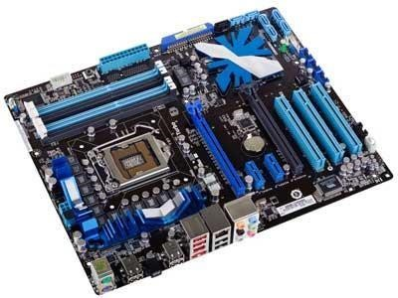

### CPU

Central Processing Unit (CPU) consists of the following features −

* CPU is considered as the brain of the computer.
* CPU performs all types of data processing operations.
* It stores data, intermediate results, and instructions (program).
* It controls the operation of all parts of the computer.

CPU itself has following three components.

* Memory or Storage Unit
* Control Unit
* ALU(Arithmetic Logic Unit)

Memory or Storage Unit

This unit can store instructions, data, and intermediate results. This unit supplies information to other units of the computer when needed. It is also known as internal storage unit or the main memory or the primary storage or Random Access Memory (RAM).

Control Unit

This unit controls the operations of all parts of the computer but does not carry out any actual data processing operations.

ALU (Arithmetic Logic Unit)

This unit consists of two subsections namely,

* Arithmetic Section
* Logic Section

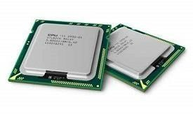

### GPU

The graphics processing unit, or GPU, has become one of the most important types of computing technology, both for personal and business computing. Designed for parallel processing, the GPU is used in a wide range of applications, including graphics and video rendering. Although they’re best known for their capabilities in gaming, GPUs are becoming more popular for use in creative production and artificial intelligence (AI).

GPUs were originally designed to accelerate the rendering of 3D graphics. Over time, they became more flexible and programmable, enhancing their capabilities. This allowed graphics programmers to create more interesting visual effects and realistic scenes with advanced lighting and shadowing techniques. Other developers also began to tap the power of GPUs to dramatically accelerate additional workloads in high performance computing (HPC), deep learning, and more.

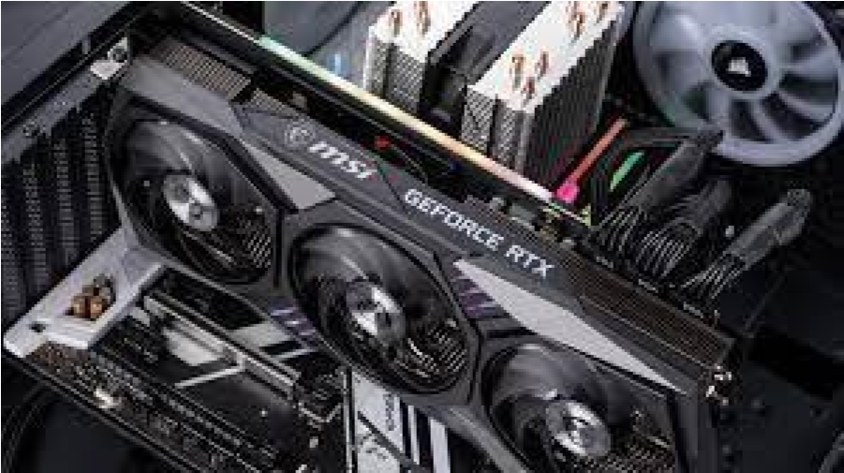

##### RAM

Alternatively referred to as **main memory**, **primary memory**, or **system memory**, **RAM** (**random-access memory**) is a hardware device that allows information to be stored and retrieved on a computer. RAM is usually associated with [DRAM,](https://www.computerhope.com/jargon/d/dram.htm) which is a type of [memory module.](https://www.computerhope.com/jargon/m/memory-module.htm) Because data is accessed randomly instead of sequentially like it is on a [CD o](https://www.computerhope.com/jargon/c/cd.htm)[r hard drive,](https://www.computerhope.com/jargon/h/harddriv.htm) [access times a](https://www.computerhope.com/jargon/a/accessti.htm)re much faster. However, unlike [ROM,](https://www.computerhope.com/jargon/r/rom.htm) RAM is a [volatile memory a](https://www.computerhope.com/jargon/v/volamemo.htm)nd requires power to keep the data accessible. If the computer is turned off, all data contained in RAM is lost.

Types of ROM

* **DRAM** (pronounced DEE-RAM), is widely used as a computer’s main memory. Each DRAM memory cell is made up of a transistor and a capacitor within an integrated circuit, and a data bit is stored in the capacitor. Since transistors always leak a small amount, the capacitors will slowly discharge, causing information stored in it to drain; hence, DRAM has to be refreshed (given a new electronic charge) every few milliseconds to retain data.
* **SRAM** (pronounced ES-RAM) is made up of four to six transistors. It keeps data in the memory as long as power is supplied to the system unlike DRAM, which has to be refreshed periodically. As such, SRAM is faster but also more expensive, making DRAM the more prevalent memory in computer systems.

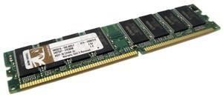

###### ROM

ROM (read only memory) is a flash memory chip that contains a small amount of **nonvolatile memory**. Non-volatile means that its contents cannot be changed and it retains its memory after the computer is turned off.ROM contains the BIOS which is the firmware for the motherboard. The BIOS contains the **bootstrap** – the program which takes the computer through steps that lead up to the loading of the operating system (OS). It happens between turning on the power and the computer beeping to say it is starting to load the OS. This process is known as **POST** (power on self test) on a PC.The **boot sequence** is the computer's initial start-up process. After the boot, the OS controls the CPU and supplies the programs to run.

Types of ROM

* **PROM** (programmable read-only memory) - manufactured as blank ROM. PROM chips can be bought cheaply and programmed directly by a programmer. They are not rewritable so they can only be programmed once.
* **EEPROM** (electrically erasable programmable read-only memory) - popular in PCs and smartphones as the firmware can be easily updated by the manufacturer. This is similar to a rewritable CD in that the chip can be reprogrammed.

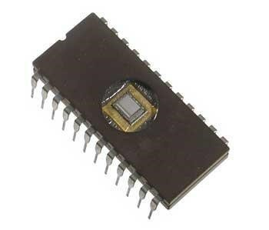

###### Daughter cards

(Or "**daughter** board", "daughtercard", "**daughter** card") The daughter board is a computer hardware. It is also known as the piggyback board, riser card, daughter board, daughtercard or daughter card. A daughter board is a printed circuit board which is connected to the motherboard or expansion card. As compared to the motherboard, it is smaller in size. A daughter board does not act as an expansion card. An expansion card adds extra new functions to the computer. But a daughter board that is connected to the motherboard adds or supports the main functions of the motherboard.

Daughter boards are directly connected to the motherboards. You know that expansion cards are connected to the motherboard by using the bus and other serial interfaces. But daughter board is directly connected to the board by soldering. As an update of the motherboard or expansion card, daughter boards are released to extend the features and services of the motherboard or expansion cards.

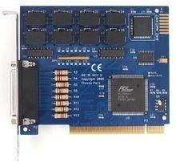

#### Bus slots

The major component that determines how the motherboard actually works is called the bus.A *bus* is nothing but a common pathway across which data can travel within a computer. This pathway is used for communication and can be established between two or more computer elements.

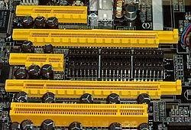

A PC has many kinds of buses, including the following:

* Processor bus

The *processor bus* is the communication pathway between the CPU and immediate support chips. These support chips are usually called the *chipset* in modern systems. This bus is used to transfer data between the CPU and the main system bus, for example, or between the CPU and an external memory cache.

* Address bus

The *address bus* actually is a subset of the processor and memory buses. In our discussion of the processor bus, you learned that a Pentium system bus consists of 64 data lines, 32 address lines (36 in a Pentium Pro or Pentium II), and a few control lines. These address lines constitute the address bus; in most block diagrams, this bus is actually considered a part of the processor and memory buses.

* I/O bus

Faster I/O speeds are necessary for better system performance. This need for higher performance involves three main areas:

* Faster CPUs
* Increasing software demands
* Greater multimedia requirements

* Memory bus

The *memory bus* is used to transfer information between the CPU and main memory--the RAM in your system. This bus is either a part of the processor bus itself, or in most cases is implemented separately by a dedicated chipset that is responsible for transferring information between the processor bus and the memory bus.

###### SMPS

A **switched-mode power supply** (**switching-mode power supply**, **switch-mode power supply**, **switched power supply**, **SMPS**, or **switcher**) is an electronic [power supply t](https://en.wikipedia.org/wiki/Power_supply)hat incorporates a [switching regulator t](https://en.wikipedia.org/wiki/Voltage_regulator#Switching_regulators)[o convert electrical power e](https://en.wikipedia.org/wiki/Electrical_power_conversion)fficiently.

Like other power supplies, an SMPS transfers power from a DC or AC source (often [mains power,](https://en.wikipedia.org/wiki/Mains_electricity) see [AC adapter)](https://en.wikipedia.org/wiki/AC_adapter) to DC loads, such as a [personal computer,](https://en.wikipedia.org/wiki/Personal_computer) while converting [voltage a](https://en.wikipedia.org/wiki/Voltage)nd [current](https://en.wikipedia.org/wiki/Electric_current) characteristics. Unlike a [linear power supply,](https://en.wikipedia.org/wiki/Linear_power_supply) the pass transistor of a switching-mode supply continually switches between low[-dissipation,](https://en.wikipedia.org/wiki/Dissipation) full-on and full-off states, and spends very little time in the high dissipation transitions, which minimizes wasted energy. A hypothetical ideal switchedmode power supply dissipates no power. [Voltage regulation i](https://en.wikipedia.org/wiki/Voltage_regulator)s achieved by varying the ratio of onto-off time (also known as [*duty cycles*).](https://en.wikipedia.org/wiki/Duty_cycle)

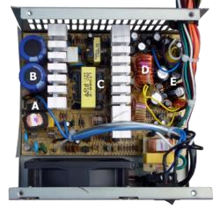

#### Interfacing ports

A port is a physical docking point using which an external device can be connected to the computer. It can also be programmatic docking point through which information flows from a program to the computer or over the Internet.

Characteristics of Ports

A port has the following characteristics −

* External devices are connected to a computer using cables and ports.
* Ports are slots on the motherboard into which a cable of external device is plugged in.
* Examples of external devices attached via ports are the mouse, keyboard, monitor, microphone, speakers, etc. Important ports

Serial port

Parallel port PS/2 port

Universal Serial Bus (or USB) Port

VGA port

Power connector

Modem port

## SPECIFICATIONS OF A COMPUTER

Computer Specifications or Specs describes the hardware specifications of a computer system. It describes the capabilities, features, and components of a computer system. It means it describes the CPU speed, RAM storage, model, and other system components. The computer specs are determined and checked usually when we have decided to purchase a new computer system or laptop, or we are a gamer. If we are already aware of what specifications are good, we will always have a fruitful deal of purchasing a new computer system.

#### Good Computer Specs

It is always good to keep in mind the points below when purchasing a new computer system or laptop. Especially if you are buying a PC or a laptop for the first time:

**CPU:** It is the central processing unit of a computer system known as the brain of a computer system. A CPU is responsible for processing all operations and providing instructions to the computer. A better CPU leads to a fast processing system. There are three variety systems currently available in the market, which are Intel i3 (remarked good), Intel i5 (remarked too good), and Intel i7 (remarked excellent). Intel i5 is sure to provide good speed and under budget, but Intel i7 is a little expensive and suitable for designers or gamers for designing software and gaming. A system with Intel i3 is the cheapest among the three.

**System Screen:** The resolution or size of a screen can also have a good impact on our selection. A 13-inch screen of a system (either laptop or PC) is the best screen size. You can also select a highresolution system but avoid purchasing a system whose screen size is below 13-inch.

**RAM:** Acronym for Random Access Memory. It is the computer memory that is responsible for executing the programs and applications. It is present in GigaBytes (GB). A system having 4GB or 8GB RAM is preferred for good computer specs. Although 16GB and 32GB RAM systems are also available, such huge RAM systems are required for high-end machines.

**Storage Space:** There are two options for Storage Space. It can be either Hard Disk Drive (HDD) or Solid State Drive (SSD). The use of HDD has become old and includes storing data on a disk, which is a slower process. SSD is the new storage type that stores data on a memory chip, and it is a faster process. Apart from these two storage types, if you are buying a computer for surfing, emails, and other online works, it is good to go for Cloud Storage that provides huge storage space for storing files, and it is the most secure place for your data. A good laptop specs must have at least 1TB for HDD and at least 256GB for SSD. The size of the SSD and HDD should not be less than the specified size.

**Graphics Card:** If you are a gamer or imager editor, you should particularly be aware of the

Graphics card a system holds. It is because, for such purposes, you should have an additional Graphics card, which is known as Advanced Graphics Card. In case you are not addicted to games, then the provided Graphics card is enough for you.

**Power Supply Unit:** It is also an essential part of a computer system responsible for sharing power to all components of the system. If a PSU is of poor quality, provides unstable power, or overheats the device, all such issues may decline the lifetime of the system. But, if PSU is good with highquality and branded, the system will operate efficiently. A good computer specs must have "80+" stickers, i.e., it should waste less than 20% of the total energy output, heavyweight PSUs that include better capacitors, larger cooling fans, heatsinks, and efficient enough to provide stable power stream to all other components of the system. The Power outputs for the desktop must be between 200 Watts to 1800 Watts. Also, a PSU should be either single-rail that carries a single high-powered plus 12V rail or multi-rail that distributes power to more than one with 12V rail. One more thing to keep in mind is that the PSU of the system must have hard-wired cables, so there will be no additional connection requirements.

So, these points, one should keep in mind while going to purchase a new laptop or a PC and buy as per the budget and requirement.

# SPECIFICATIONS OF DESKTOP COMPUTERS

**Recommended Configurations**

We recommend systems that meet or exceed the following specifications:

|  |  |
| --- | --- |
| **Processor (CPU):**  **Operating System:** | Intel Core i5 (10th generation or newer) or equivalent  Microsoft [**Windows 10 Professional** x](https://www.umass.edu/it/support/software/azure-dev-tools-for-teaching-no-cost-software-education-research)64  (free via [**Azure Dev Tools for Teaching**.](https://www.umass.edu/it/support/software/azure-dev-tools-for-teaching-no-cost-software-education-research) Restrictions apply.) |
| **Memory:**  **Storage:** | 8 GB RAM  512 GB internal Solid State Drive (SSD) or 1 TB internal HDD |
| **Sustainability** | EPEAT Silver rating (preferably EPEAT Gold) |
| **Monitor/Display:** | 24" LCD monitor |
| **Network Adaptor:** | 802.11ac 2.4/5 GHz wireless adapter |
| **Other:** | Webcam, lock, external drive for backups |

**Minimum Requirements**

We support the following minimum computer configurations.

**Note:** The following lists minimum requirements that allow for network connectivity and other basic functions. If you are planning on purchasing a new computer, please use the recommended configurations above.

**Processor (CPU):** Intel Core i3 (sixth generation or newer) or equivalent

**Operating** Microsoft [**Windows 10** x](https://www.umass.edu/it/support/software/azure-dev-tools-for-teaching-no-cost-software-education-research)64 **System:**

(free via [**Azure Dev Tools for Teaching**.](https://www.umass.edu/it/support/software/azure-dev-tools-for-teaching-no-cost-software-education-research) Restrictions apply.)

|  |  |
| --- | --- |
| **Memory:** | 8 GB RAM |
| **Storage:** | 500 GB internal storage drive |

**Monitor/Display:** 15" LCD monitor

**Other:** 802.11ac 2.4/5 GHz wireless adapter